The Stewardship Program

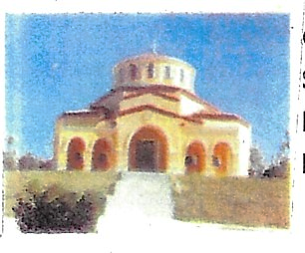
Christian Stewardship is Everyone's
Responsibility

Q — What is Stewardship?
A — Stewardship is the giving of time, talent and financial support to our church and its ministries.

Q — What is the Stewardship Program?
A — The Stewardship program is a Christian way to offer support to our church spiritual, physical and financial needs
.
Q — What should my Stewardship pledge be?
A — As a rule of thumb, give according to your means and conscience. In terms of time, remember that time is the most valuable commodity we have, and so it is a tremendous gift. Concerning talent, the Lord wants us to use our talents primarily to build His Kingdom here on earth. For many people, giving between 10% to 15% of income is a good benchmark in terms of financial stewardship.

Q —Who should make a commitment?
A — Everyone who is 18 years of age and older who is self-supporting and wants to take his or her responsibility to support their church.

Q — How do I make a pledge?
A — Simply fill out the pledge form attached below and then place it in the collection basket on Sunday or mail it to the church, P.O. Box 192, Lecanto, FL 34460-0192.

Q — How do I fulfill my Stewardship pledge?
A — If you ask to be contacted by our Priest, or a member of the stewardship committee, then share with them how you can best offer your time and talent. For your financial offering, weekly or monthly offerings are recommended because it is easy to manage.
You can use the weekly coupons that will be sent to you. You can return the coupon with your contribution by placing it in the collection basket on Sunday or mail to the church POB address above.

Q — Can I change my pledge if a personal financial crisis arises?
A — Of Course. In fact, it is helpful to do so that we can adjust our records to reflect your new situation.
And your pledge is confidential.
All you need do is contact our Priest or the Parish Council President to review your needs.

For Christ and His Ministries
My Stewardship Commitment Pledge to Archangel Michael Church

Yes, please contact me to discuss my desire to offer my talent and/or time for our Church.

I will give a total of $ ___________per week as follows:

to the General Operating Fund to the Building Fund

I will give a total of $ ____________per month to the

"Mortgage Buster" Special Pledge ($100 X 40 stewards = $4,000)

Name

Address

City | State | Zip
Telephone (Area Code and Number) | E-mail Address
Date

